Project Design Phase
Problem – Solution Fit Template
Date | 30 September 2026
Team ID | SWUID2026286057
Project Name | Implement Client Script & UI Policy (Incident)
Maximum Marks | 2 Marks
Problem – Solution Fit Template:
The Problem-Solution Fit simply means that you have found a problem with your customer and that the solution you have realized for it actually solves the customer's problem. It helps entrepreneurs, marketers and corporate innovators identify behavioral patterns and recognize what would work and why.
Purpose:
- Solve complex problems in a way that fits the state of your customers.
- Succeed faster and increase your solution adoption by tapping into existing mediums and channels of behavior.
- Sharpen your communication and marketing strategy with the right triggers and messaging.
- Increase touch-points with your company by finding the right problem-behavior fit and building trust by solving frequent annoyances, or urgent or costly problems.
- Understand the existing situation in order to improve it for your target group.
Problem Statement:
Service Desk Agents spend valuable time manually typing caller details and correcting incomplete or invalid data on the ServiceNow Incident form, because the form has no automatic filling and only static validation after saving. This project implements a Client Script and UI Policy on the Incident form to auto-populate fields and apply dynamic validations, so incidents are logged faster and without manual errors.
The completed canvas is on the next page and the same content is explained point by point after it.

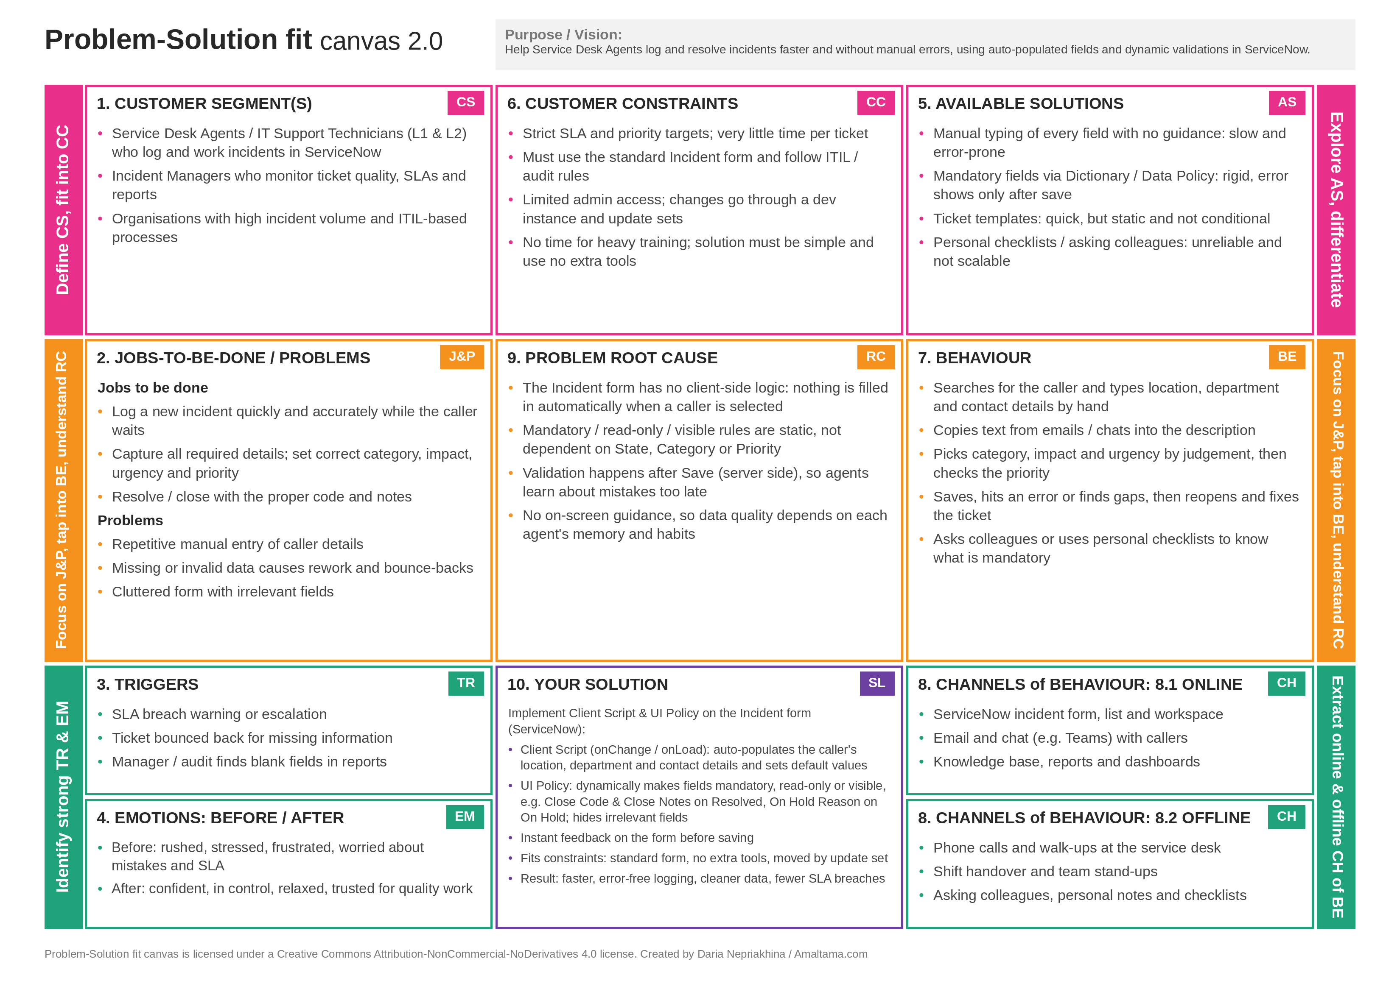

Problem – Solution Fit: Section-wise Details
Canvas Section | Content
1. Customer Segment(s) (CS) | Service Desk Agents / IT Support Technicians (L1 & L2) who log and work incidents in ServiceNow; Incident Managers who monitor ticket quality, SLAs and reports; organisations with high incident volume and ITIL-based processes.
2. Jobs-to-be-Done / Problems (J&P) | Jobs: log a new incident quickly and accurately while the caller waits; capture all required details and set the correct category, impact, urgency and priority; resolve or close with the proper code and notes. Problems: repetitive manual entry of caller details, missing or invalid data causing rework and bounce-backs, and a cluttered form with irrelevant fields.
3. Triggers (TR) | SLA breach warning or escalation; ticket bounced back for missing information; manager or audit finds blank fields in reports.
4. Emotions: Before / After (EM) | Before: rushed, stressed, frustrated, worried about mistakes and SLA. After: confident, in control, relaxed and trusted for quality work.
5. Available Solutions (AS) | Manual typing of every field (slow, error-prone); mandatory fields through Dictionary / Data Policy (rigid, error only after save); ticket templates (quick but static); personal checklists and asking colleagues (unreliable, not scalable).
6. Customer Constraints (CC) | Strict SLA and priority targets with very little time per ticket; must use the standard Incident form and follow ITIL / audit rules; limited admin access, so changes go through a dev instance and update sets; no time for heavy training, so the solution must be simple and use no extra tools.
7. Behaviour (BE) | Searches for the caller and types location, department and contact details by hand; copies text from emails and chats; picks category, impact and urgency by judgement; saves, hits an error, then reopens and fixes the ticket; asks colleagues or uses checklists to know what is mandatory.
8.1 Channels of Behaviour: Online | ServiceNow incident form, list and workspace; email and chat (e.g. Teams) with callers; knowledge base, reports and dashboards.
8.2 Channels of Behaviour: Offline | Phone calls and walk-ups at the service desk; shift handover and team stand-ups; asking colleagues, personal notes and checklists.
9. Problem Root Cause (RC) | The Incident form has no client-side logic, so nothing is filled in when a caller is selected; mandatory, read-only and visible rules are static and do not depend on State, Category or Priority; validation happens after Save on the server, so mistakes are found too late; there is no on-screen guidance, so data quality depends on each agent's memory.
10. Your Solution (SL) | Implement a Client Script and UI Policy on the Incident form. The Client Script (onChange / onLoad) auto-populates the caller's location, department and contact details and sets default values. The UI Policy dynamically makes fields mandatory, read-only or visible, for example Close Code and Close Notes when the state is Resolved and On Hold Reason when On Hold, and hides irrelevant fields. Agents get instant feedback before saving. The solution fits the constraints (standard form, no extra tools, moved by update set) and results in faster, error-free logging, cleaner data and fewer SLA breaches.
References:
- https://www.ideahackers.network/problem-solution-fit-canvas/
- https://medium.com/@epicantus/problem-solution-fit-canvas-aa3dd59cb4fe

